Reception - Spring 2 – Spring has Sprung!
Communication and Language
Listening, attention and understanding:
Children are encouraged to ask questions to find out more and develop their understanding.

Speaking: Children talk about the life cycles of plants and animals using key vocabulary. They can describe signs of spring. Children articulate their ideas and thoughts with talk partners. They start to describe events in more detail.
Personal, Social and Emotional Development
Physical Development

Self-Regulation:
Identifying the problem and how they are feeling.
Expressing their feelings.
Managing Self:
Develop problem solving skills. Think about the possible choices and find solutions to conflicts.
Building Relationships:
Considering the feelings of others.
Talk to others to solve conflicts.
Come up with solutions with friends.

Gross Motor Skills:
Games. Developing ball handling skills – handling ball, passing to self, passing to others (send and receive). Developing accuracy, control, appropriate force and catching skills.

Fine Motor Skills:
Playdough, cutting, threading, painting, drawing, sticking, measuring, building and funky finger activities.

Mathematics
Literacy
Days of the week and measuring time.
Comparing height and length.
3D shapes.
Pattern.
Number:
Representing and sorting 9 and 10.
Comparing numbers within 10.
Making 10.
Numerical Patterns:
Adding more.
Expressive Arts and Design
Creating with Materials:
Mother’s Day cards, Easter cards, painting spring flowers, signs of spring pictures. Draw with increasing complexity and detail.
Being Imaginative and Expressive:
Begin to develop more complex stories using small world equipment. Create collaboratively, inventing narratives and stories with peers. Remember and sing entire songs – number songs, rhymes.

Past and Present: The Christian Story of Easter.
People, Culture and Communities: Celebrating Easter – egg hunts, egg decorating, egg rolling, signs of new life and new beginnings. Comic Relief and supporting others.
The Natural World: Children investigate the seasonal changes that spring brings. Signs of spring. Life cycle of a plant, life cycle of a butterfly.
Understanding the World
Comprehension: Anticipate what happens next in stories. Engage in extended conversations about stories.
Word Reading: Continue to support with sound-blending. Consolidation of phase 2 and phase 3 sounds. Read some common exception (tricky) words.
Word Writing: Focus on correct letter formation - lower case and introduce some capital letters. Cards, labelling pictures and simple sentences.

Spring has Sprung!
Family Participation:  ● Tapestry.  ● Compliments from home.  ● Focus Child.  ● Reading books. | Key Texts:  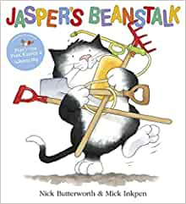  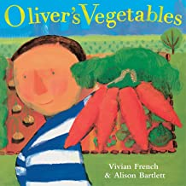  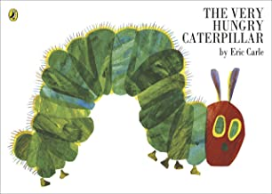  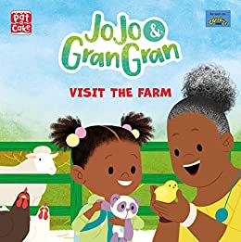  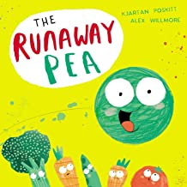 | Paths:  ● The children will be learning about how to solve problems. This is an extremely important skill that children will need all through life.  ● Part of solving problems is making choices.  ● Some choices are OK and some are not OK.  ●We will be looking at the following steps –  - Identify the problem.  - Identify the feeling.  - Think of your choices.  - Judge the choices and pick a solution.
Trips/Activities/  Enrichment Ideas:  ● Show and tell.  ● Shrove Tuesday.  ● Butterfly garden.  ● Planting seeds.  ● Comic Relief.  ● Mother’s Day.  ● Learning together day (Music).  ● Spring walk.  ● Easter. |  | Key Vocabulary:  ● Cocoon  ● Shoots/Buds  ● Nest  ● Life Cycle  ● Baby animals – chick, lamb, calf.  ● Hatch  ● Days of the week  ● Soil
Reception - Spring 2 – Spring has Sprung!

