Reception – Summer 1 – Fantastic Fairy Tales!
Communication and Language
Listening, attention and understanding:
Children listen to and talk about fairy tales to build familiarity and understanding.

Speaking: Children articulate their ideas and thoughts with talk partners. They start to describe events in more detail. Children can retell some traditional tales with actions/ picture prompts. They use story language when acting out a narrative.
Personal, Social and Emotional Development
Physical Development

Self-Regulation:
Introduction of more feelings through the PATHS scheme. Children can acknowledge some of their feelings and use strategies developed through PATHS to help regulate these.
Managing Self:
Discuss why we take turns, wait politely, say excuse me, tidy up and strive to be ‘ready, respectful and safe’ at school.
Building Relationships:
Continue to problem solve with peers and try to be helpful and encouraging when it comes to supporting others.

Gross Motor Skills: PE - GAMES
Continue developing ball handling skills – handling ball, passing to self, passing to others (send and receive). Developing accuracy, control, appropriate force and catching skills. Encourage obstacle building/Climbing on new A frames outside. Scooter/Trike time on playground. Fine Motor Skills:
Playdough, cutting, threading, painting, drawing, sticking, measuring, building and funky finger activities.

Mathematics
Literacy
Fantastic Fairy Tales!
Matching shapes, matching models, replicating models, tangrams.
Number:
Building and recognising numbers to 20 and beyond.
Adding more.
Taking away.
Numerical Patterns:
Counting beyond 20.
Odd and Even numbers.
Doubles.

Expressive Arts and Design
Creating with Materials: Pictures are more recognisable. Draw pictures of key characters and their features. Painting outdoors. Colour mixing. Creating settings from stories. Building houses for The Three Little Pigs, make a scene from Goldilocks and the Three Bears/Jack and the Beanstalk.
Being Imaginative and Expressive: Use of actions to retell Tales. Story maps, puppets and props to support retelling and acting. Children to create collaboratively and role play various Tales.

Past and Present: Kings, Queens. Princesses and Princes in Fairy Tales, fictional characters and creatures.
People, Culture and Communities: Royal family today – Coronation of King Charles III.
The Natural World: Observational pictures and paintings of the natural world. Settings in Tales and how they compare to the world around us. Changing seasons. Continue with life cycles, planting a bean.
Understanding the World
Comprehension: Children can explain the main events of a story. They can describe key characters.
Word Reading: Consolidation of phase 3 sounds. Start of Phase 4 – CVCC, CCVC, CCVCC, CCCVC words. Longer words, compound words. Introduce more common exception (tricky) words.
Word Writing: Character labelling and descriptions. Simple sentences, story maps, retelling key events in stories.
Family Participation:  ● Tapestry.  ● Compliments from home.  ● Focus Child.  ● Reading books. | 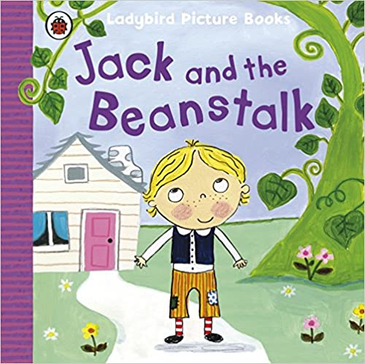  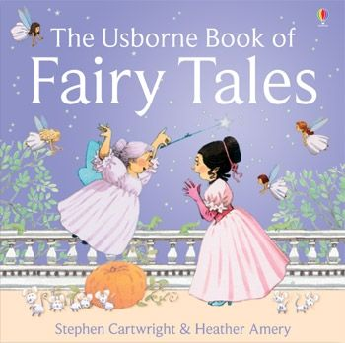  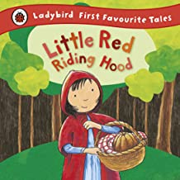  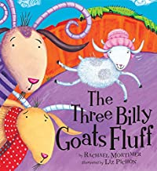  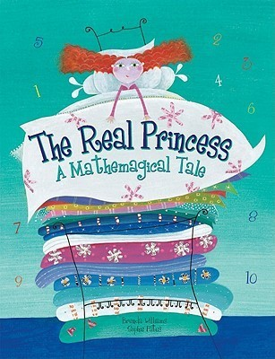  Key Texts  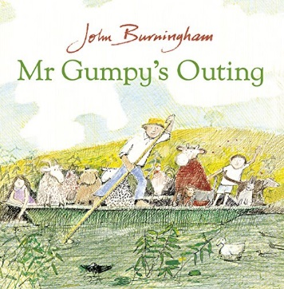  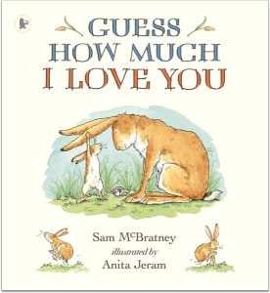  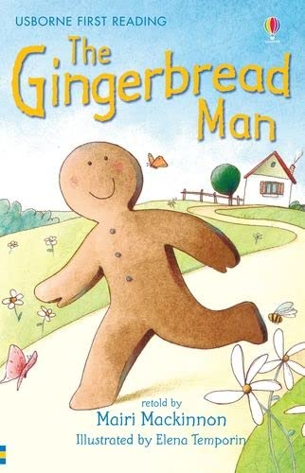  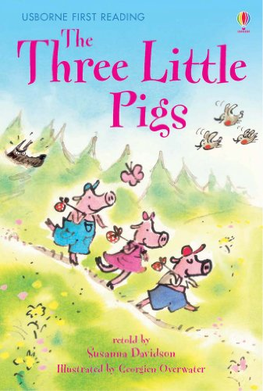 | Paths:  ● The children will be learning about different types of feelings including:  ● Tired  ● Frustrated  ● Proud  ● Love  ● Worried  ● Disappointed  ● We recognise that some of these are comfortable and some of these are uncomfortable feelings.
Trips/Activities/  Enrichment Ideas:  ● Show and tell.  ● Learning together day.  ● King Charles III Coronation Celebrations.  ● Once Upon a Time – trip to Gressenhall (13th June).  ● Planting a bean. |  | Key Vocabulary:  ● Fairy Tale  ● Beanstalk  ● Character  ● Setting  ● Giant  ● Wolf  ● Magic  ● King  ● Coronation
Reception – Summer 1 – Fantastic Fairy Tales!

