Reception – Autumn 2 – Let’s Celebrate!
2023-2024

Communication and Language
Listening, attention and understanding:
● Children listen to and talk about stories to build familiarity and understanding. ● They listen carefully to rhymes and songs, paying attention to how they sound. ● They learn rhymes, poems, and songs.
Speaking:
● Children talk about experiences and celebrations and start to describe events in more detail. ● Modelling and support so that children articulate their thoughts in fuller sentences.

Personal, Social and Emotional Development
Physical Development

Gross motor skills:
● Exploring body shapes. ● Rolls as a method of travel. ● Confidently moving around, under and over apparatus. ● Apply a method of travel/a jump/a turn and a body shape to apparatus.
Fine motor skills:
● Dough disco.
● Cutting, sticking, threading, painting, colouring, drawing.

Self-Regulation:
● Feelings are ok – it is ok to feel sad and angry at times. However not all behaviours because of these emotions are acceptable.
Managing Self:
● How to manage some of these more uncomfortable emotions (such as anger).
● PATHS - Do the turtle.
Building Relationships:
● Think about and consider the feelings of others.

Mathematics
Literacy
Past and Present: ● Children talk about family celebrations – birthdays, Christenings, weddings, achievements, parties.
People, Culture and Communities: ● Give consideration to children less fortunate (Children in Need). ● Diwali ● The story of Guy Fawkes and Bonfire Night. ● How Christmas is celebrated in different countries/cultural traditions and the traditional story of Christmas.
The Natural World: ● Children celebrate and investigate the seasonal changes that Autumn brings.
Comprehension:
● Supported reading groups.
● Daily story time.
Word Reading:
● Digraphs, tricky words,
oral blending, CVC words.
● Help children to read the sounds speedily to support with sound-blending.
Word Writing:
● Development of tripod grip. ● Name writing, initial sounds, CVC words and labelling.

● Shape and positional language.
● Comparing size, mass and capacity.
● Age and birthday celebrations.
Number:
● Representing 1,2,3,4 and 5.
● Sorting, matching, and comparing 1-5.
● Matching numerals and picture cards.
Numerical Patterns:
● Sequencing of events.
● Composition of numbers.
● One more, one less.
● More than, fewer than.

Let’s Celebrate!
Expressive Arts and Design
Creating with Materials: ● Use of natural resources to create an Autumnal picture. ● Firework/Bonfire night creations.
● Celebration cards. ● Christmas crafts.
Being Imaginative and Expressive: ● Role play ● Retelling of parts of ‘Stickman.’ ● Use of the dressing up provision. ● Performing songs with others as part of the Nativity, and where appropriate trying to move in time with the music. ● Use of resources for props.

Understanding the World
Family Participation:  ● Tapestry  ● Compliments from home  ● Sharing family celebrations  ● Reading books | Key Texts  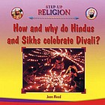  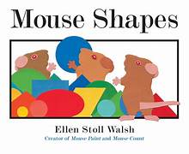  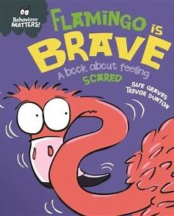  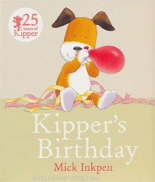  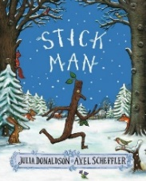  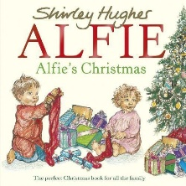  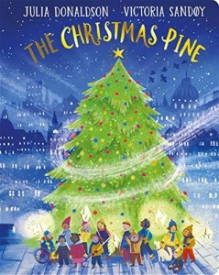 | PATHS:  ● We continue with our Child of the Week. They receive compliments from their friends, teacher and are also asked to give a compliment for themselves and one from home.  ● We make a distinction between feelings and behaviours.  ● Young children may not be able to tell the difference between feelings and behaviours, but we can help them understand that it is OK to have uncomfortable feelings (such as anger and sadness) and talk about them.
Trips/Activities/  Enrichment Ideas:  ● Autumn walk  ● Children in Need  ● Trip to Holkham  ● Pantomime  ● Show and tell  ● Nativity  ● Posting cards/letters |  | Key Vocabulary:  ● Celebrate  ● Christmas  ● Festival  ● Bonfire  ● Diwali  ● Safety  ● Trust  ● Behaviour  ● Feeling  ● Digraph  ● Tricky Word
Reception – Autumn 2 – Let’s Celebrate!

